**Acropolis Institute Of Technology And Research,**

**Indore(M.P.)**



**Subject – Database Management System (DBMS)**

**(CY-405)**

**Name – Prajal Tale**

**Enrollment No. - 0827CY221042**

**Branch - CS(Cyber Security)**

**Semester- 4th sem**

**Submitted To –Mrs. Nidhi Nigam Ma’am**

**Index**

|  |  |  |  |  |
| --- | --- | --- | --- | --- |
| **Sr.No.** | **Experiment** | **Date of Exp.** | **Date of sub.** | **Grade** |
| 1. | To study DBMS and RDBMS, its characteristic comparisons and study of popular DB software. | 11/03/24 | 2/03/24 |  |
| 2. | To study of MYSQL, features and installation of MYSQL. | 18/3/24 | 2/04/24 |  |
|  |  |  |  |  |
|  |  |  |  |  |
|  |  |  |  |  |
|  |  |  |  |  |
|  |  |  |  |  |
|  |  |  |  |  |
|  |  |  |  |  |
|  |  |  |  |  |
|  |  |  |  |  |
|  |  |  |  |  |

**Assignment -2**

**Aim:-**

To study of MYSQL, features and installation of MYSQL.

**What is MySQL ?**

MySQL is an open-source [**Relational Database Management System**](https://www.hostinger.com/tutorials/dbms) (RDBMS) that enables users to store, manage, and retrieve structured data efficiently. It is widely used for various applications, from small-scale projects to large-scale websites and enterprise-level solutions.

There are a few elements of MySQL. Let’s take a closer look at them:

### Database

In relation to MySQL, a database is a structured collection of data organized and stored in tables. It serves as a central repository where information is efficiently managed, allowing users to store, retrieve, update, and delete data. MySQL provides the software framework to create, maintain, and interact with these databases, making data storage and retrieval seamless and reliable.

### Client-Server Model

Computers that install and run RDBMS software are called clients. Whenever they need to access data, they connect to the RDBMS server.

MySQL is one of many RDBMS software options. RDBMS and MySQL are often thought to be the same because of MySQL’s popularity. A few [**big web applications**](https://stackshare.io/mysql) like Facebook, Twitter, YouTube, Google, and Yahoo! all use MySQL for data storage purposes. Even though it was initially created for limited usage, it is now compatible with many important computing platforms like Linux, macOS, Microsoft Windows, and Ubuntu.

### SQL

[**MySQL and SQL are not the same**](https://www.hostinger.com/tutorials/difference-between-mysql-and-sql-server). Be aware that MySQL is one of the most popular RDBMS software’s brand names, which implements a client-server model.

The client and server use a domain-specific language – Structured Query Language (SQL) to communicate in an RDBMS environment. If you ever encounter other names that have SQL in them, like [**PostgreSQL**](https://www.hostinger.com/tutorials/how-to-install-postgresql-on-ubuntu/) and Microsoft SQL server, they are most likely brands which also use Structured Query Language syntax. RDBMS software is often written in other programming languages but always uses SQL as its primary language to interact with the database. MySQL itself is written in **C** and **C++**.

SQL tells the server what to do with the data. In this case, SQL statements can instruct the server to perform certain operations:

* **Data query** – requesting specific information from the existing database.
* **Data manipulation** – adding, deleting, changing, sorting, and other operations to modify the data, the values or the visuals.
* **Data identity** – defining data types, e.g. changing numerical data to integers. This also includes defining a [**schema**](https://www.hostinger.com/tutorials/database-schema) or the relationship of each table in the database
* **Data access control** – providing security techniques to protect data. This includes deciding who can view or use any information stored in the database

### Open-Source

Open-source means that you’re free to use and modify it. You can also learn and customize the source code to better accommodate your needs. However, The GPL ([**GNU Public License**](https://www.gnu.org/licenses/gpl-3.0.en.html)) determines what you can do depending on the conditions. The commercially licensed version is available if you need more flexible ownership and advanced support.

## Why is MySQL So Popular?

MySQL is indeed not the only RDBMS on the market, but it is one of the most popular ones. The fact that many major tech giants rely on it further solidifies the well-deserved position. Here are some of the reasons.

1. **Flexible and Easy To Use**

As open-source software, you can modify the source code to suit your need and don’t need to pay anything. It includes the option for upgrading to the advanced commercial version. The installation process is relatively simple, and shouldn’t take longer than 30 minutes.

1. **High Performance**

A wide array of cluster servers backs MySQL. Whether you are storing massive amounts of big eCommerce data or doing heavy business intelligence activities, MySQL can assist you smoothly with optimum speed.

1. **An Industry Standard**

Industries have been using MySQL for years, which means that there are abundant resources for skilled developers. MySQL users can expect rapid development of the software and freelance experts willing to work for a smaller wage if they ever need them.

1. **Secure**

Your data should be your primary concern when choosing the right RDBMS software. With its Access Privilege System and User Account Management, MySQL sets the security bar high. Host-based verification and password encryption are both available.

### **How query works?**

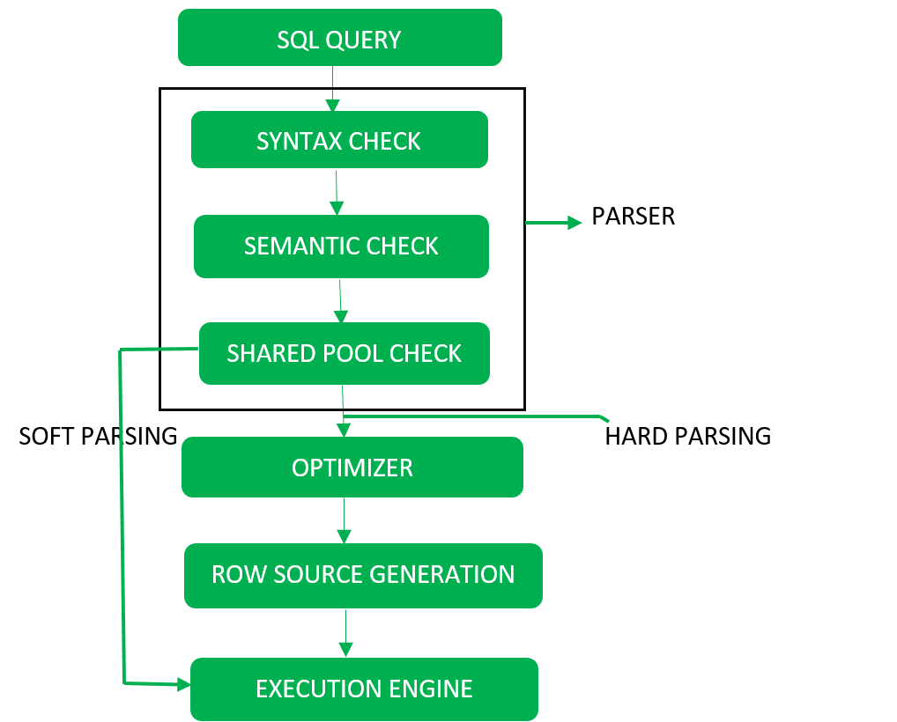

File manger and transcation manger

### **Download MySQL**

Follow these steps:

**Step 1:** Go to the [official website](https://dev.mysql.com/downloads/installer/) of MySQL and download the community server edition software. Here, you will see the option to choose the Operating System, such as Windows.

**Step 2:** Next, there are two options available to download the setup. Choose the version number for the MySQL community server, which you want. If you have good internet connectivity, then choose the mysql-installer-web-community. Otherwise, choose the other one.

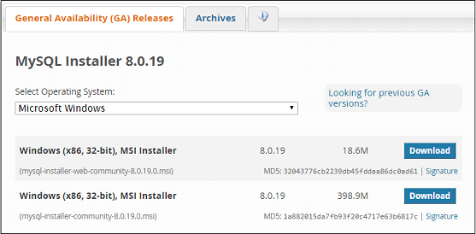

**Installing MySQL on Windows**

**Step 1:** After downloading the setup, unzip it anywhere and double click the MSI **installer .exe file.** It will give the following screen:

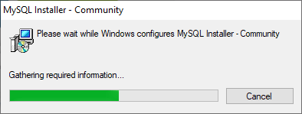

**Step 2:** In the next wizard, choose the **Setup Type**. There are several types available, and you need to choose the appropriate option to install MySQL product and [features](https://www.javatpoint.com/mysql-features). Here, we are going to select the **Full** option and click on the Next button.

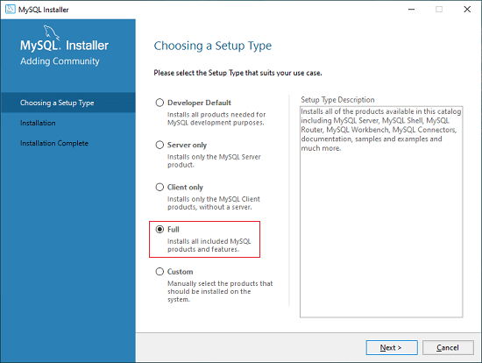

This option will install the following things: MySQL Server, MySQL Shell, MySQL Router, [MySQL Workbench](https://www.javatpoint.com/mysql-workbench), MySQL Connectors, documentation, samples and examples, and many more.

**Step 3:** Once we click on the Next button, it may give information about some features that may fail to install on your system due to a lack of requirements. We can resolve

them by clicking on the **Execute** button that will install all requirements automatically or can skip them. Now, click on the Next button.

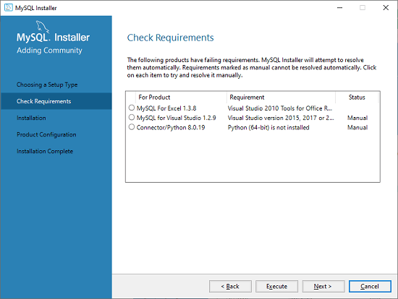

**Step 4:** In the next wizard, we will see a dialog box that asks for our confirmation of a few products not getting installed. Here, we have to click on the **Yes** button.

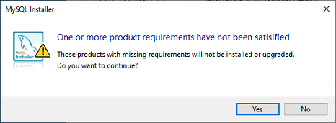

After clicking on the Yes button, we will see the list of the products which are going to be installed. So, if we need all products, click on the Execute button.

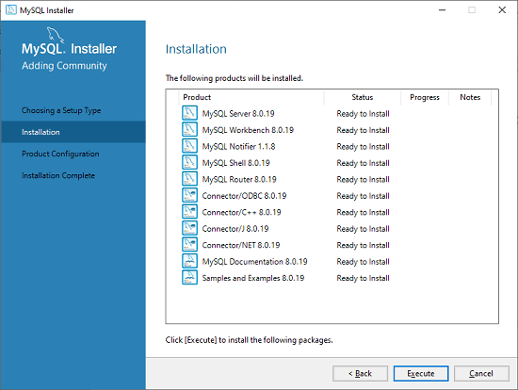

**Step 5:** Once we click on the Execute button, it will download and install all the products. After completing the installation, click on the Next button.

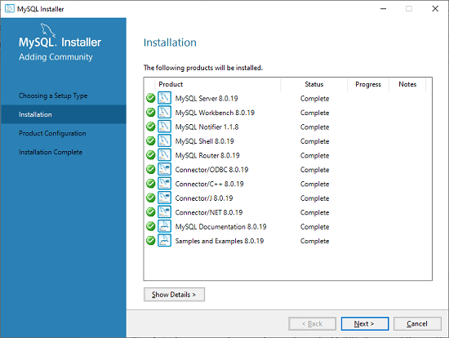

**Step 6:** In the next wizard, we need to configure the MySQL Server and Router. Here, I am not going to configure the Router because there is no need to use it with MySQL. We are going to show you how to configure the server only. Now, click on the Next button.

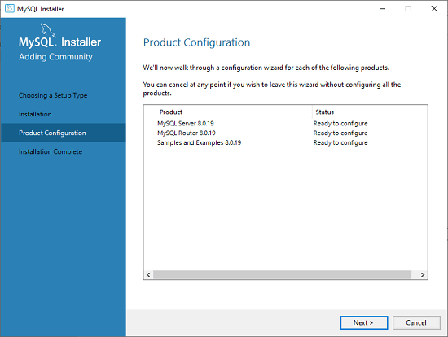

**Step 7:** As soon as you will click on the Next button, you can see the screen below. Here, we have to configure the MySQL Server. Now, choose the Standalone MySQL Server/Classic MySQL Replication option and click on Next. Here, you can also choose the InnoDB Cluster based on your needs.

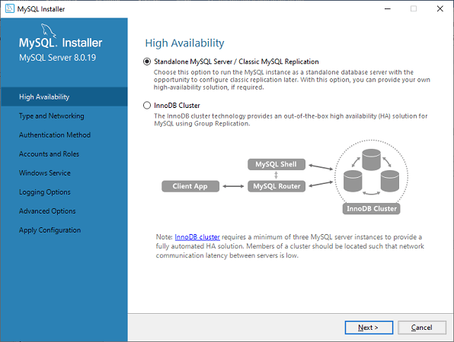

**Step 8:** In the next screen, the system will ask you to choose the Config Type and other connectivity options. Here, we are going to select the **Config Type** as 'Development Machine' and Connectivity as **TCP/IP,** and **Port Number** is 3306, then click on Next.

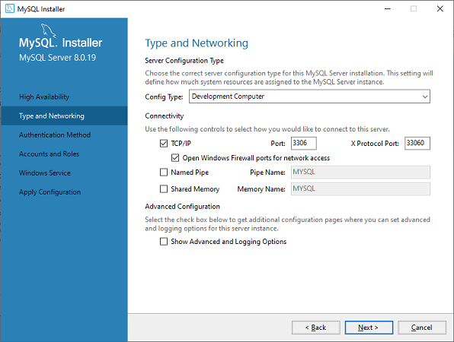

**Step 9:** Now, select the Authentication Method and click on Next. Here, I am going to select the first option.

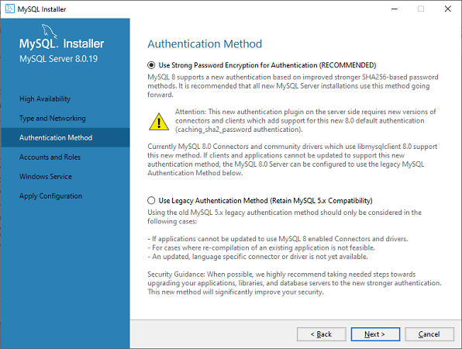

**Step 10:** The next screen will ask you to mention the MySQL Root Password. After filling the password details, click on the Next button.

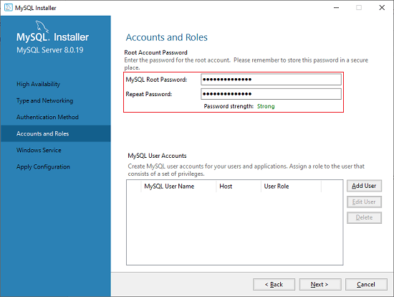

**Step 11:** The next screen will ask you to configure the Windows Service to start the server. Keep the default setup and click on the Next button.

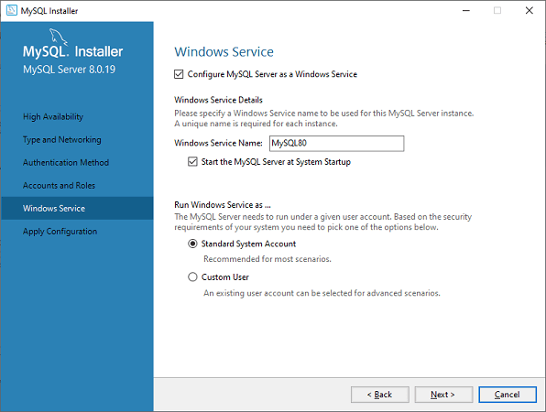

**Step 12:** In the next wizard, the system will ask you to apply the Server Configuration. If you agree with this configuration, click on the Execute button.

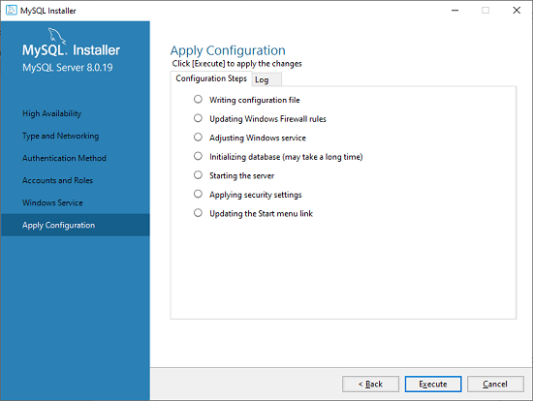

**Step 13:** Once the configuration has completed, you will get the screen below. Now, click on the **Finish** button to continue.

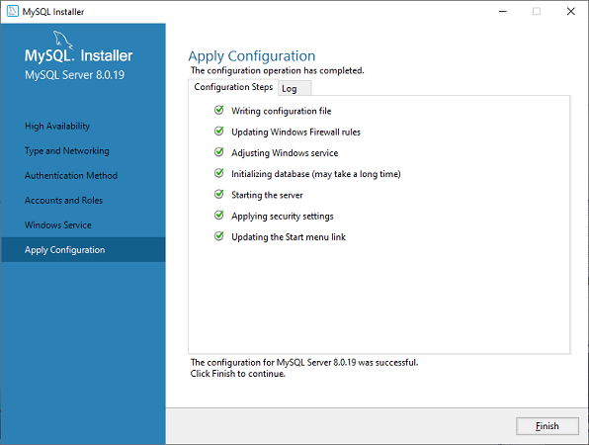

**Step 14:** In the next screen, you can see that the Product Configuration is completed. Keep the default setting and click on the Next-> Finish button to complete the MySQL package installation.

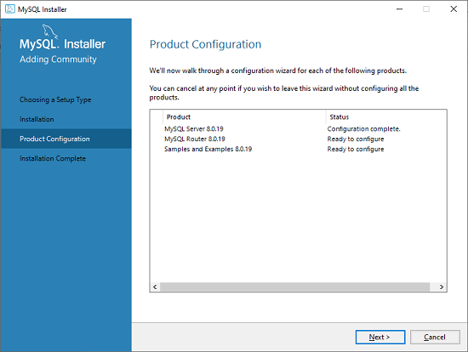

**Step 15:** In the next wizard, we can choose to configure the Router. So click on Next->Finish and then click the Next button.

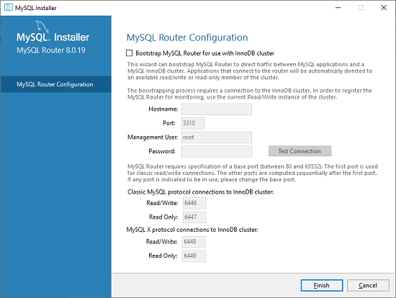

**Step 16:** In the next wizard, we will see the Connect to Server option. Here, we have to mention the root password, which we had set in the previous steps.

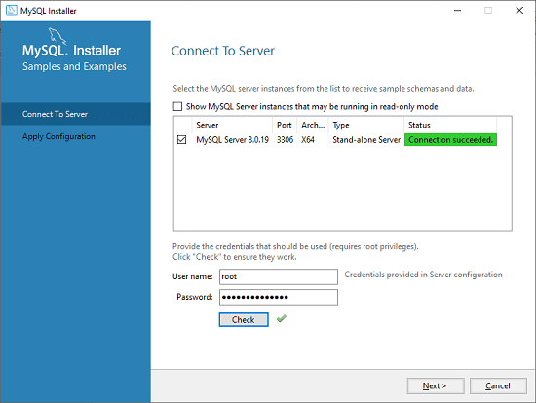

In this screen, it is also required to check about the connection is successful or not by clicking on the Check button. If the connection is successful, click on the Execute button. Now, the configuration is complete, click on Next.

**Step 17:** In the next wizard, select the applied configurations and click on the Execute button.

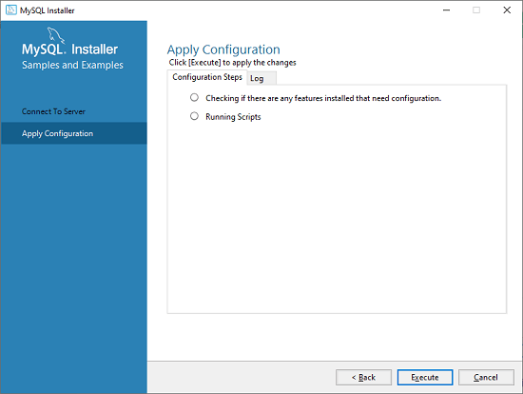

**Step 18:** After completing the above step, we will get the following screen. Here, click on the Finish button.

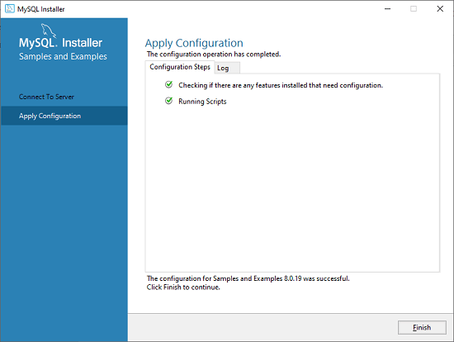

**Step 19:** Now, the MySQL installation is complete. Click on the Finish button.

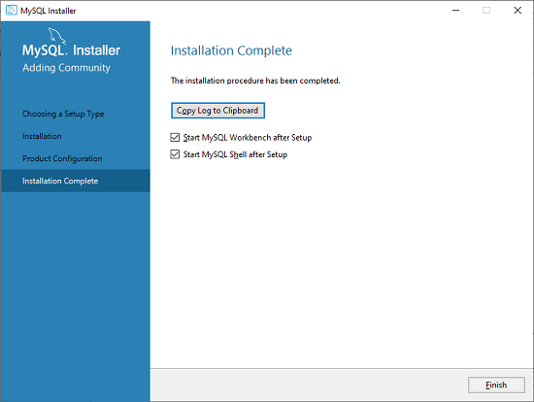

### **Verify MySQL installation**

Once MySQL has been successfully installed, the base tables have been initialized, and the server has been started, you can verify its working via some simple tests.

Open your MySQL **Command Line Client**; it should have appeared with a **mysql> prompt**. If you have set any password, write your password here. Now, you are connected to the MySQL server, and you can execute all the SQL command at mysql> prompt as follows:

**For example**: Check the already created databases with show databases command:

